Back in August, it was arguable who was winning the race for president. Unsatisfied with polls-based approaches for a variety of reasons, I turned to the Intrade markets. There are two metrics you can look at to see who traders think is winning at any given time. One is the relative prices of “Obama to win 2008 US Presidential Election” vs. “McCain to win 2008 US Presidential Election.” The other is the number of electoral votes Obama and McCain are each expected to win.
Let’s focus first on the overall chance of winning. If we look at the relative price metric over the past couple months, we see that Barack Obama has been winning consistently by on average 60/40 except for a brief period in mid-September. For convenience, I’ll express the metric as Obama / (Obama + McCain). This is the pink line in figure 1.
In my previous column, I described a system for simulating the joint dynamics of the 51 electoral markets on Intrade forward to Election Day. One can extract from this, what is the probability of Intrade’s state market prices on November 4th predicting an Obama electoral victory. That is the blue line in figure 1. In principle, the blue line and the pink line should be roughly the same if you accept the big assumption that the next month may be similar (in volatility and state-to-state correlation) to the last 3 months. As you can see, the simulation has much greater dynamic range than the simple “X to win 2008 US Presidential Election” contracts. The markets react sharply, and this metric reflects that without delay.
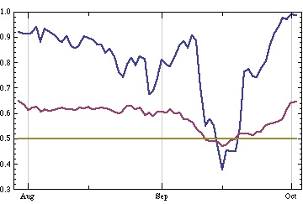
Is it credible to say that Obama has a >95% chance of winning the real-world election? He does have a very big lead and there’s not that much time left. But the overall Obama wins the election contract is trading below 70. I will address that in some detail in my next column, but what this really says is there may be significant trading opportunities between the national contracts, the state contracts, and the weekly options.

The other metric we can look at is the expected number of electoral votes for Obama (or McCain). In figure 2, in pink, we see the history of the Intrade electoral vote predictor for Obama, which assigns each state’s votes depending on who’s contract has the higher price that day. In figure 2, in blue, we see the mean of Obama’s electoral votes from my simulation. Typically, these two lines are quite close, which is a good validation of the simulation. The gap is indicative of the predicted average net effect of states flipping from their current status between the measurement date and Election Day. Since the simulated mean is usually below the electoral vote predictor, Intrade’s state market traders are implying Obama’s lead is a little soft. But the reason the simulation still produces a predicted win for Obama >95% of the time going forward from today is that he does have a really formidable lead in the Intrade state markets.

